**Lesson 7: Translating and Solving Equations**

**Do Now:**

**Do your best to solve these problems (Hint: try to express these equations into sentences, using what you learned from the previous lessons):**

1. **Find b if b+4 = 5**
2. **Find c if c – 3 = 10**
3. **Find a if 2a = 12**
4. **Find d if d/3 = 12**

**Key Vocabulary:**

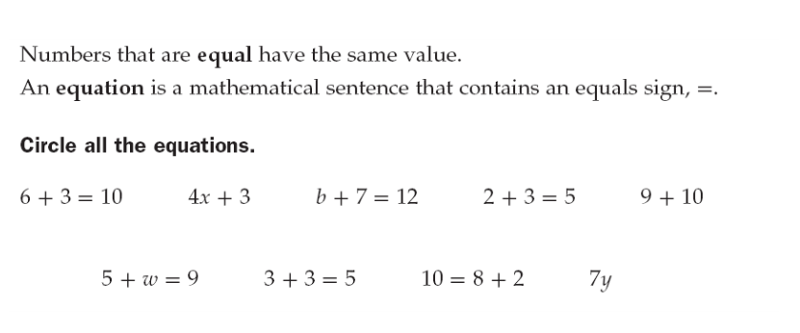

**Guided Notes:**

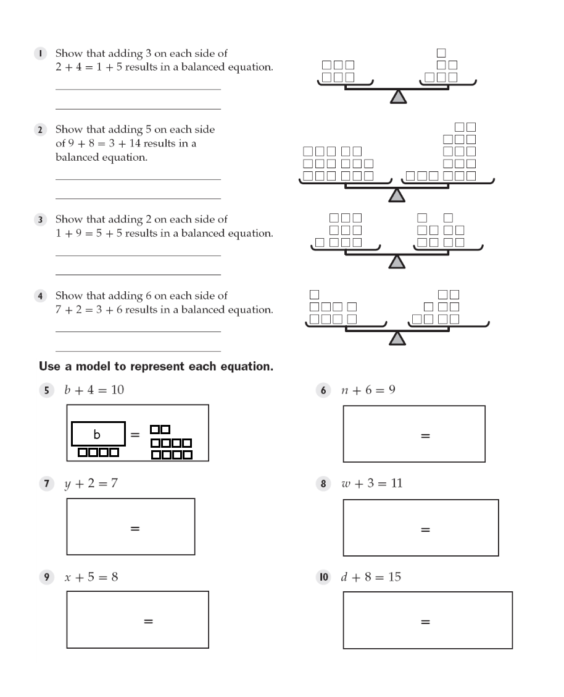

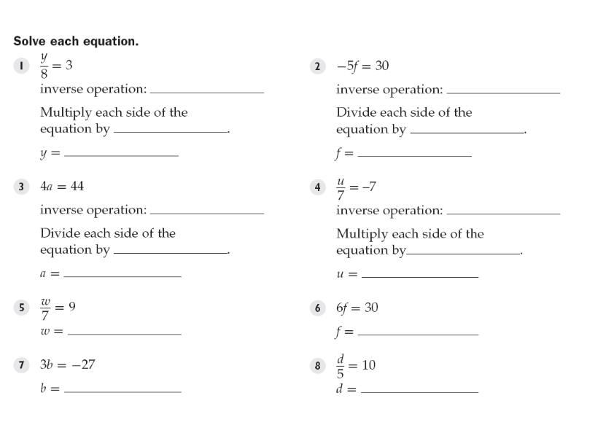

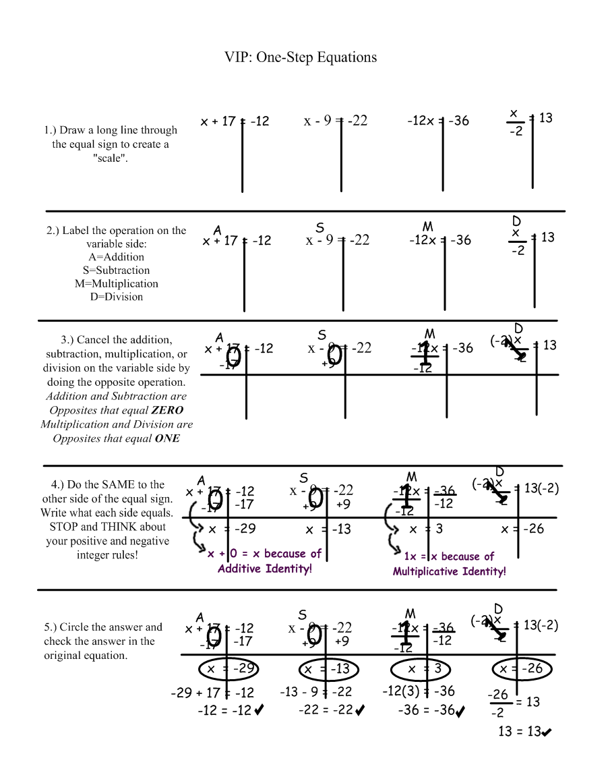

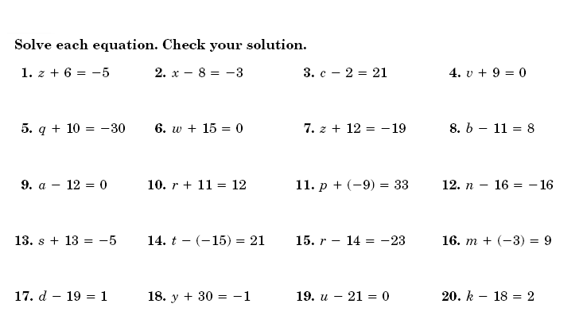

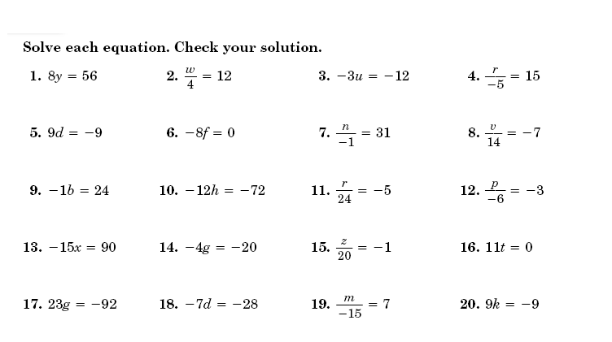

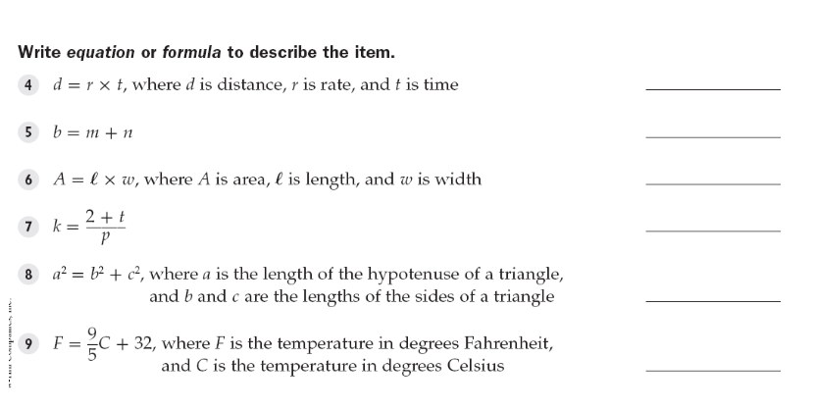

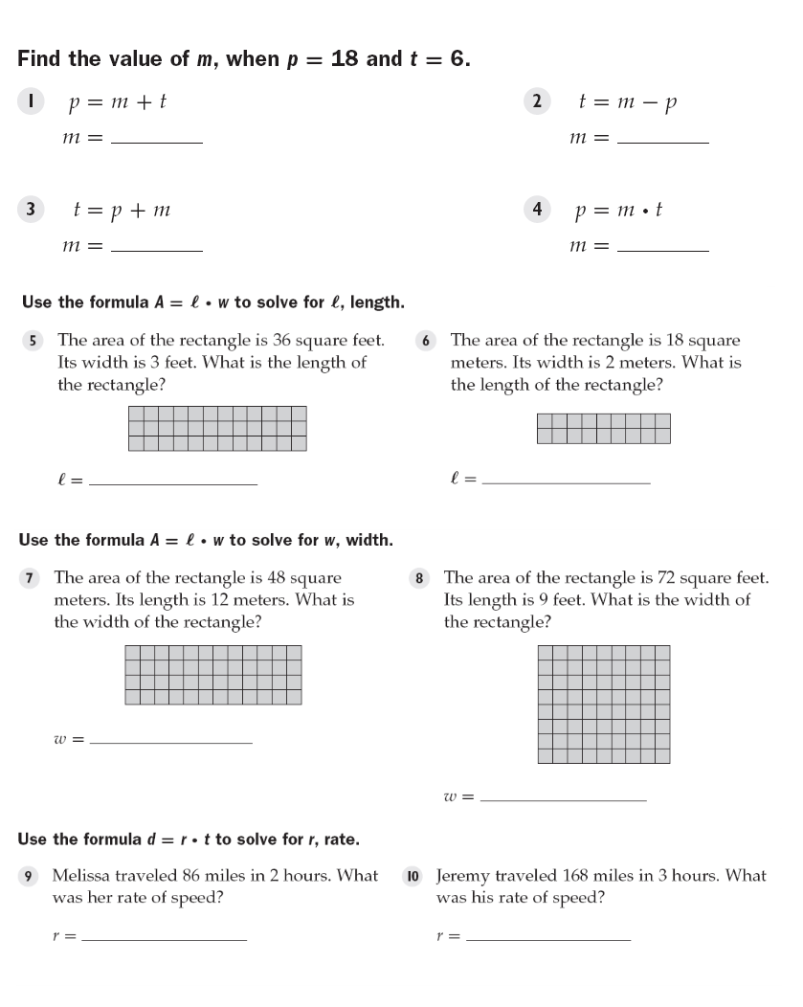

**Structured/Guided Practice:**

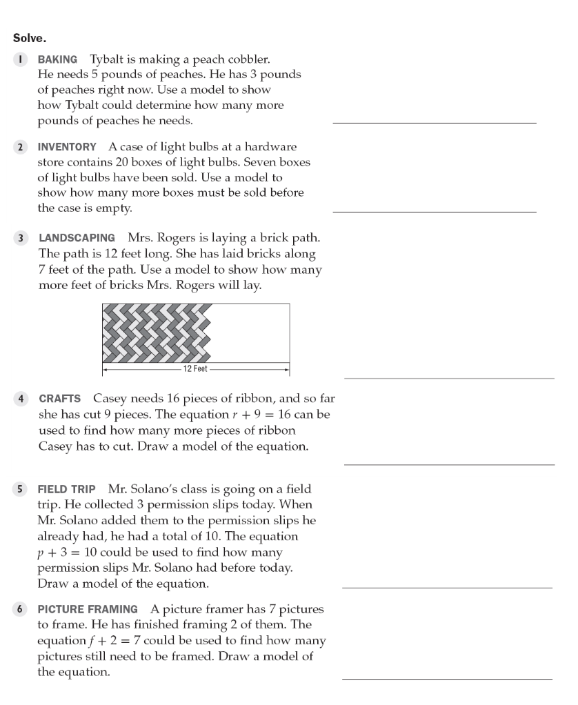

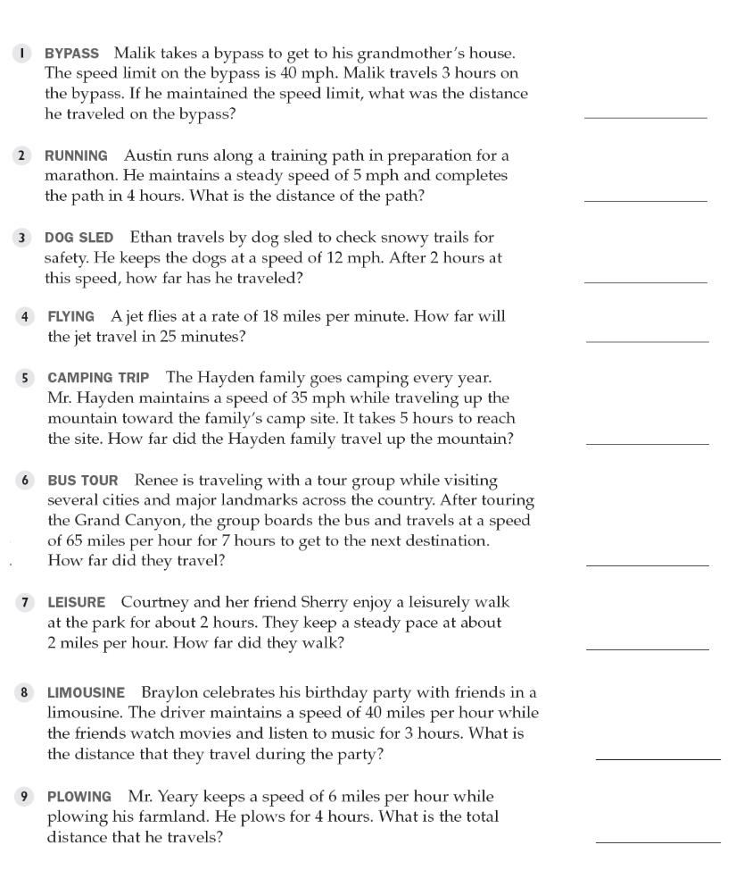

**Independent Practice:**

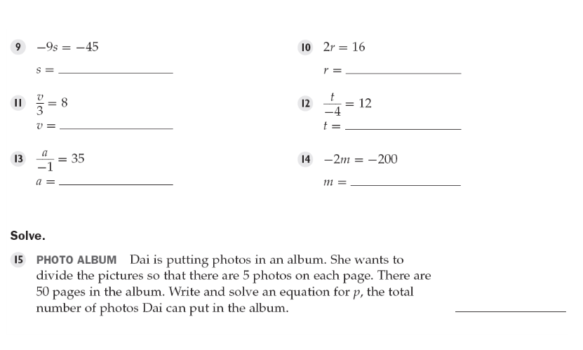

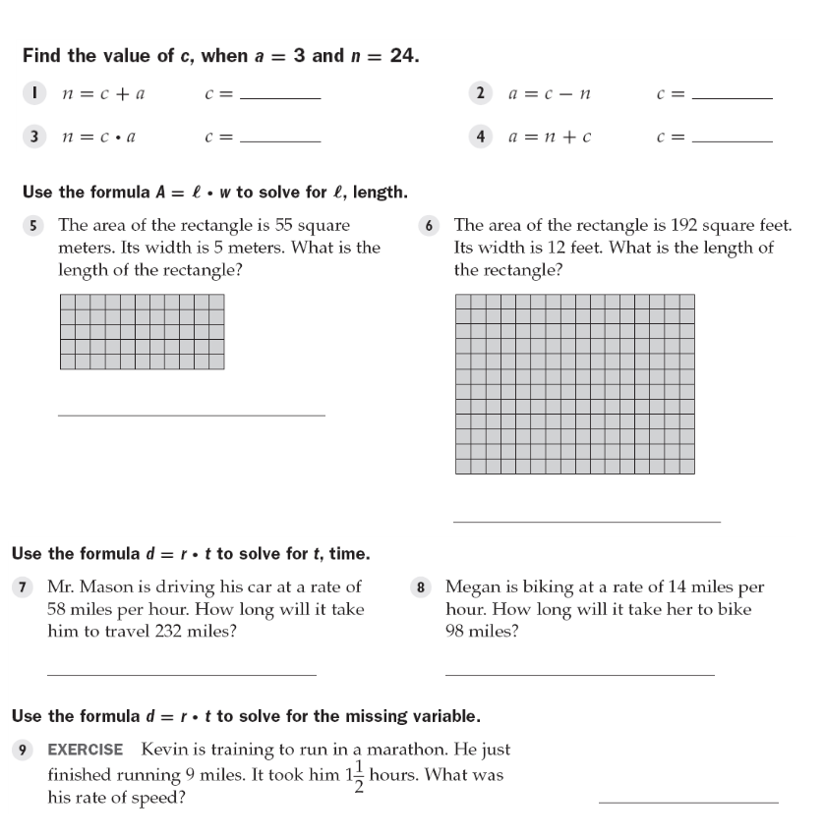

**Closure:**

